ISLAMIC UNIVERSITY OF TECHNOLOGY
DHAKA, BANGLADESH
ORGANIZATION OF ISLAMIC COOPERATION
DATABASE MANAGEMENT SYSTEMS LAB

Name: Antara Arifa Mullick
Student ID: 210042132
Department: Computer Science and Engineering
Program: B.Sc. in Software Engineering

Report preparing for Lab Task
Task 1:
Write SQL statements to create the following tables with the given specifications:
a) DOCTOR:
NAME | VARCHAR2(20) | (e.g.: MR. X, MR. Y)
SPECIALIZATION | CHAR(2) | (e.g. CS, GS, IM, ER)
FEE | NUMBER | (e.g. 2000, 1500)
Primary Key(NAME,
SPECIALIZATION)

Solution Approach:
CREATE TABLE DOCTOR
(
NAME VARCHAR2 (20) ,
SPECIALIZATION CHAR (2) ,
FEE NUMBER ,
CONSTRAINT PK_DOCTOR PRIMARY KEY ( NAME , SPECIALIZATION )
);

SQL Command:
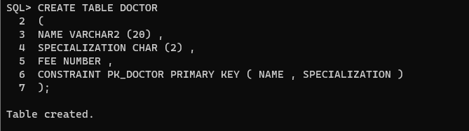

b) PATIENT:
PATIENT_NO | CHAR(5) | (e.g.: P-101) Primary Key
NAME | VARCHAR2(20) | (e.g.: A, B, C) Not Null
ADDRESS | VARCHAR2(10) | (e.g.: DHK, KHL, etc.)

Solution Approach:
CREATE TABLE PATIENT
(
PATIENT_NO CHAR (5),
NAME VARCHAR2 (20) ,
ADDRESS VARCHAR(10),
CONSTRAINT PK_PATIENT PRIMARY KEY ( PATIENT_NO )
);

SQL Command:
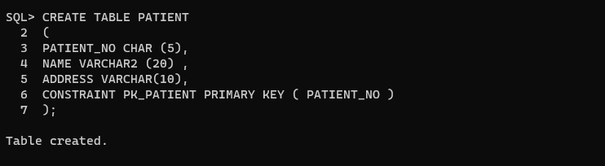
c) APPOINTMENT:
PATIENT_NO | CHAR(5) | (e.g.: P-101)
NAME | VARCHAR2(20) | (e.g.: MR. X, MR. Y)
SPECIALIZATION | CHAR(2) | (e.g. CS, GS, IM, ER)
Primary
Key(PATIENT_NO,
NAME,SPECIALIZATION)

Solution Approach:
CREATE TABLE APPOINTMENT
(
PATIENT_NO CHAR (5),
NAME VARCHAR2 (20) ,
SPECIALIZATION CHAR(2),
CONSTRAINT PK_APPOINTMENT PRIMARY KEY ( PATIENT_NO, NAME, SPECIALIZATION )
);

SQL Command:
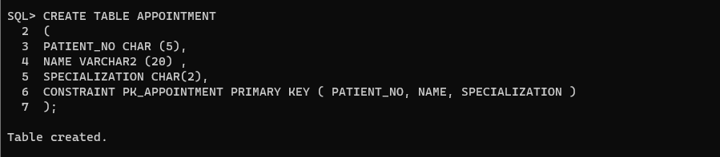

Task 2:
Write SQL statements to perform the following alteration operations:
(a)Add a new attribute ‘APPOINTMENT_DATE’ (DATE type) in APPOINTMENT table.
Solution Approach:
ALTER TABLE APPOINTMENT
ADD APPOINTMENT_DATE DATE;

SQL Command:
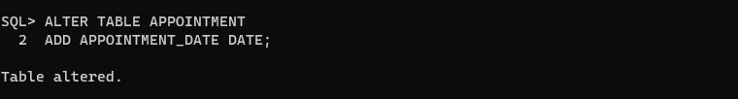
(b) Modify the PRIMARY KEY of APPOINTMENT table and add APPOINTMENT_DATE too with
the previous ones.
Solution Approach:
ALTER TABLE APPOINTMENT
DROP CONSTRAINT PK_APPOINTMENT;

ALTER TABLE APPOINTMENT
ADD CONSTRAINT PK_APPOINTMENT primary key (PATIENT_NO, NAME, SPECIALIZATION, APPOINTMENT_DATE);
SQL Command:
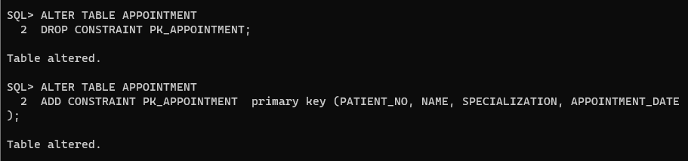
(c) Rename the attribute PATIENT_NO, NAME from APPOINTMENT table to P_NO and D_NAME
respectively.
Solution Approach:
ALTER TABLE APPOINTMENT
RENAME COLUMN PATIENT_NO TO P_NO;

ALTER TABLE APPOINTMENT
RENAME COLUMN NAME TO D_NAME;

SQL Command:
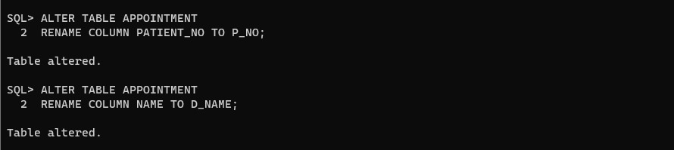
(d) Rename the table APPOINTMENT to APPOINTMENT_INFO.
Solution Approach:
ALTER TABLE APPOINTMENT
RENAME TO APPOINTMENT_INFO;

SQL Command:
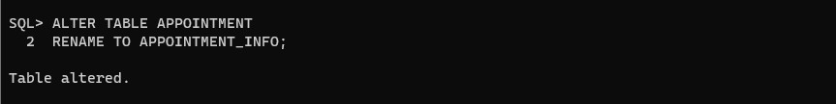
(e) Add two foreign key constraints FK_APPOINTMENT_DOCTOR and FK_APPOINTMENT_PATIENT
that identifies D_NAME,SPECIALIZATION and P_NO as foreign keys.
Solution Approach:
ALTER TABLE APPOINTMENT_INFO
ADD CONSTRAINT FK_APPOINTMENT_DOCTOR
FOREIGN KEY (D_NAME, SPECIALIZATION) REFERENCES DOCTOR(NAME, SPECIALIZATION);

ALTER TABLE APPOINTMENT_INFO
ADD CONSTRAINT FK_APPOINTMENT_PATIENT
FOREIGN KEY (P_NO) REFERENCES PATIENT(PATIENT_NO);

SQL Command:
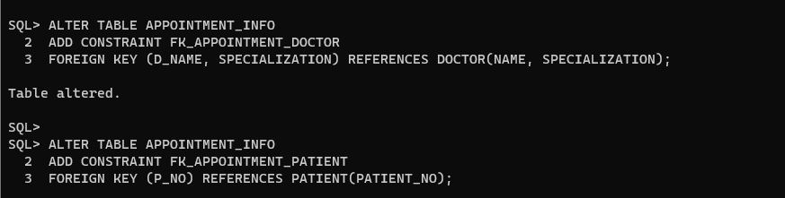
Task 3:
Insert at least 3 records in each table following the example.
VALUES ('P-103', 'MR. X', 'CS', TO_DATE('2023-08-27', 'YYYY-MM-DD'));
INSERT INTO DOCTOR (NAME, SPECIALIZATION, FEE) VALUES ('MR. X', 'CS', 2000);
INSERT INTO DOCTOR (NAME, SPECIALIZATION, FEE) VALUES ('MR. Y', 'GS', 1500);
INSERT INTO DOCTOR (NAME, SPECIALIZATION, FEE) VALUES ('MR. Z', 'GS', 2500);

INSERT INTO PATIENT (PATIENT_NO, NAME, ADDRESS) VALUES ('P-101', 'A', 'DHK');
INSERT INTO PATIENT (PATIENT_NO, NAME, ADDRESS) VALUES ('P-102', 'B', 'KHL');
INSERT INTO PATIENT (PATIENT_NO, NAME, ADDRESS) VALUES ('P-103', 'C', 'DHK');

INSERT INTO APPOINTMENT_INFO (P_NO, D_NAME, SPECIALIZATION, APPOINTMENT_DATE)
VALUES ('P-101', 'MR. X', 'CS', TO_DATE('2023-08-25', 'YYYY-MM-DD'));
INSERT INTO APPOINTMENT_INFO (P_NO, D_NAME, SPECIALIZATION, APPOINTMENT_DATE)
VALUES ('P-102', 'MR. Y', 'GS', TO_DATE('2023-08-26', 'YYYY-MM-DD'));
INSERT INTO APPOINTMENT_INFO (P_NO, D_NAME, SPECIALIZATION, APPOINTMENT_DATE)
VALUES ('P-103', 'MR. X', 'CS', TO_DATE('2023-08-27', 'YYYY-MM-DD'));
SQL Command:
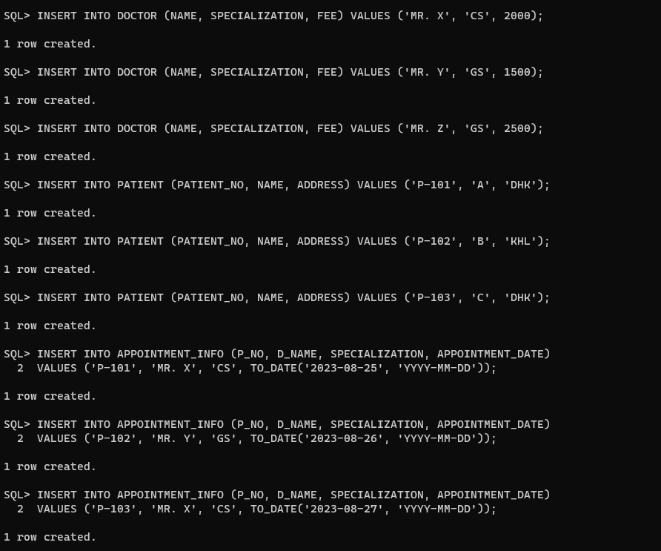

Task 4:
Write SQL statements to answer the following queries:
(a)Find all the Doctors’ names whose fees are less than 1500.
Solution Approach:
SELECT NAME FROM DOCTOR WHERE FEE < 1500;

SQL Command:
(b)Find all the Patients’ names who live in ‘KHL’ city.
Solution Approach:
SELECT NAME FROM PATIENT WHERE ADDRESS = 'KHL';

SQL Command:
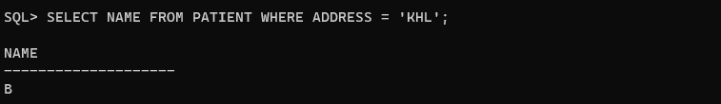

(c)Show the result of Cartesian Product between PATIENT and APPOINTMENT_INFO table.
Solution Approach:
SELECT * FROM PATIENT, APPOINTMENT_INFO;

SQL Command:
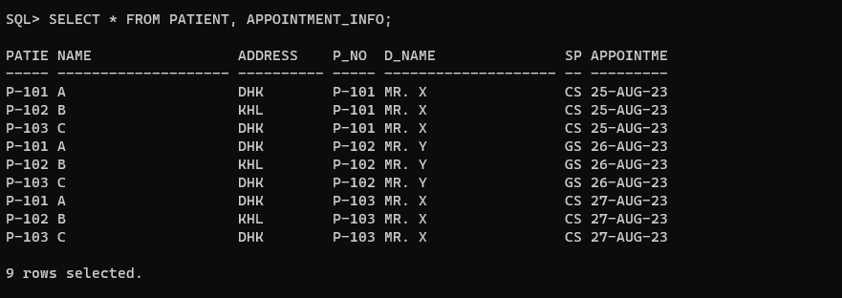
(d)Show the result of Natural Join between PATIENT and APPOINTMENT_INFO table.
Solution Approach:
SELECT * FROM PATIENT
NATURAL JOIN APPOINTMENT_INFO;
SQL Command:
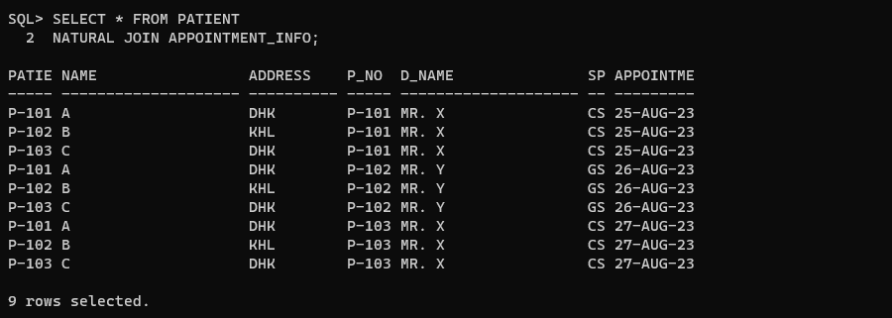

(e)Find all the Patient’s names and their address who have an appointment today.
Solution Approach:
SELECT P.NAME, P.ADDRESS
FROM PATIENT P
JOIN APPOINTMENT_INFO A ON P.PATIENT_NO = A.P_NO
WHERE A.APPOINTMENT_DATE = TRUNC(SYSDATE);

SQL Command:
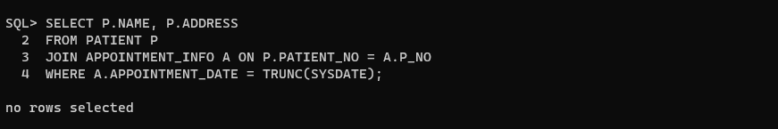
(f)Find all the Doctor-related information who have patients from ’DHK’.
Solution Approach:
SELECT DISTINCT D.*
FROM DOCTOR D
JOIN APPOINTMENT_INFO A ON D.NAME = A.D_NAME AND D.SPECIALIZATION = A.SPECIALIZATION
JOIN PATIENT P ON A.P_NO = P.PATIENT_NO
WHERE P.ADDRESS = 'DHK';

SQL Command:
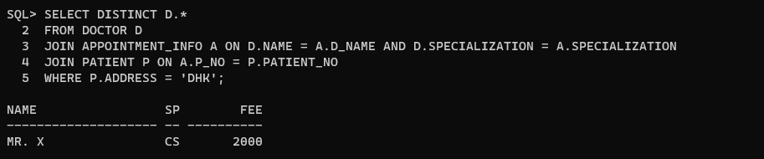

(g) Find all Patient-related information who has an appointment with a doctor of ’GS’ spe-
cialization or a doctor whose fee is greater than 1500.

Solution Approach:

SELECT DISTINCT P.*
FROM PATIENT P
JOIN APPOINTMENT_INFO A ON P.PATIENT_NO = A.P_NO
JOIN DOCTOR D ON A.D_NAME = D.NAME AND A.SPECIALIZATION = D.SPECIALIZATION
WHERE D.SPECIALIZATION = 'GS' OR D.FEE > 1500;

SQL Command:

Task 5:
Write following DML statements:
a)Update the NAME and ADDRESS of a tuple from ’A’ and ’DHK ’ to ’K’ and ’RAJ’ accordingly.
Solution Approach:
UPDATE PATIENT SET NAME = 'K', ADDRESS = 'RAJ' WHERE NAME = 'A' AND ADDRESS = 'DHK';

SQL Command:

a)Update the NAME of table DOCTOR from ’MR. Y’ as ’Ms. Y’.

ALTER TABLE APPOINTMENT_INFO
DROP CONSTRAINT FK_APPOINTMENT_DOCTOR;

UPDATE DOCTOR SET NAME = 'Ms. Y' WHERE NAME = 'MR. Y';

UPDATE APPOINTMENT_INFO SET D_NAME = 'Ms. Y' WHERE D_NAME = 'MR. Y';

ALTER TABLE APPOINTMENT_INFO
ADD CONSTRAINT FK_APPOINTMENT_DOCTOR
FOREIGN KEY (D_NAME, SPECIALIZATION) REFERENCES DOCTOR(NAME, SPECIALIZATION);

SQL Command: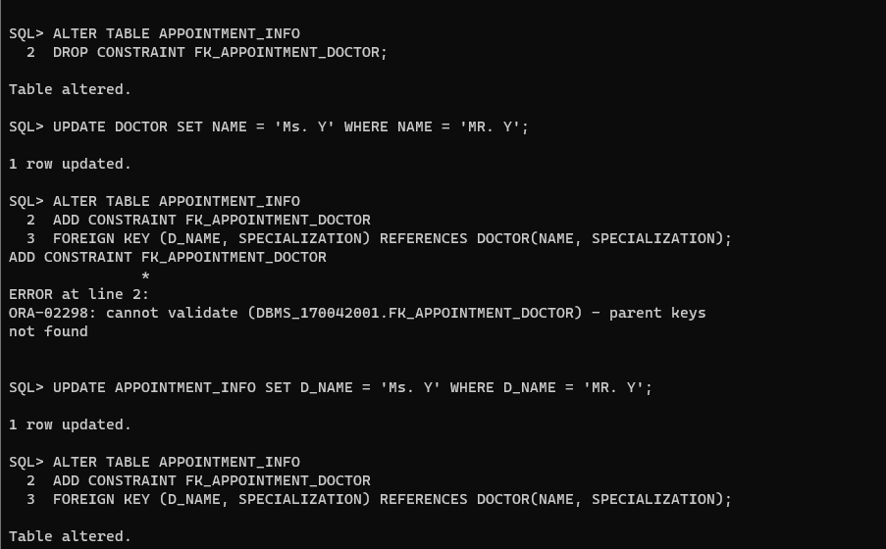
c)Delete Patient with PATIENT_NO P-101.
Solution Approach:
ALTER TABLE APPOINTMENT_INFO
DROP CONSTRAINT FK_APPOINTMENT_PATIENT;

DELETE FROM PATIENT WHERE PATIENT_NO = 'P-101';

SQL Command:
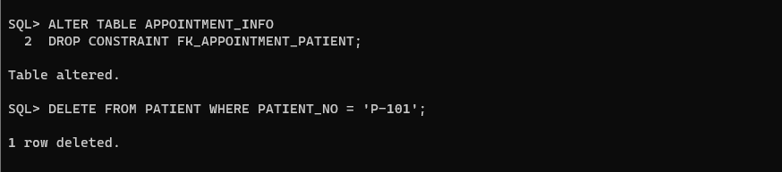
(d)Delete all the information without deleting the table structure.
Solution Approach:
TRUNCATE TABLE APPOINTMENT_INFO;

ALTER TABLE APPOINTMENT_INFO
DISABLE CONSTRAINT FK_APPOINTMENT_DOCTOR;
TRUNCATE TABLE DOCTOR;

TRUNCATE TABLE PATIENT;

INSERT INTO DOCTOR (NAME, SPECIALIZATION, FEE) VALUES ('MR. X', 'CS', 2000);
INSERT INTO DOCTOR (NAME, SPECIALIZATION, FEE) VALUES ('Ms. Y', 'GS', 1500);

INSERT INTO PATIENT (PATIENT_NO, NAME, ADDRESS) VALUES ('P-101', 'A', 'DHK');
INSERT INTO PATIENT (PATIENT_NO, NAME, ADDRESS) VALUES ('P-102', 'B', 'KHL');
INSERT INTO PATIENT (PATIENT_NO, NAME, ADDRESS) VALUES ('P-103', 'C', 'DHK');

INSERT INTO APPOINTMENT_INFO (P_NO, D_NAME, SPECIALIZATION, APPOINTMENT_DATE)
VALUES ('P-101', 'MR. X', 'CS', TO_DATE('2023-08-25', 'YYYY-MM-DD'));
INSERT INTO APPOINTMENT_INFO (P_NO, D_NAME, SPECIALIZATION, APPOINTMENT_DATE)
VALUES ('P-102', 'Ms. Y', 'GS', TO_DATE('2023-08-26', 'YYYY-MM-DD'));
INSERT INTO APPOINTMENT_INFO (P_NO, D_NAME, SPECIALIZATION, APPOINTMENT_DATE)
VALUES ('P-103', 'MR. X', 'CS', TO_DATE('2023-08-27', 'YYYY-MM-DD'));

SQL Command: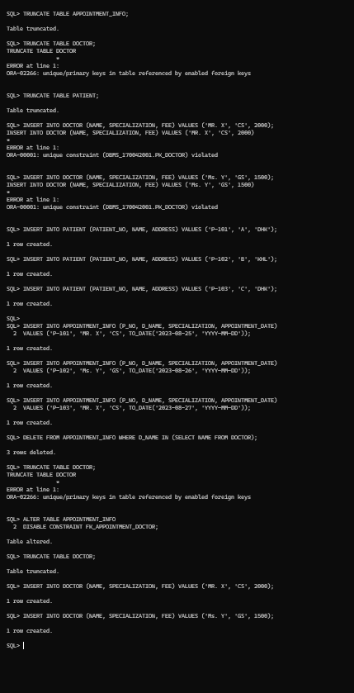

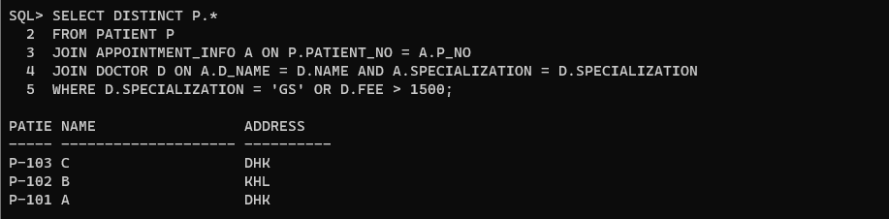
Problems Faced:
1. Syntax Errors in CREATE TABLE Statements:
- Incorrect syntax in the CREATE TABLE statement resulted in table creation failures.
- Solution: Double-checking the syntax against SQL documentation or examples to ensure accuracy.
2. Data Integrity Issues in INSERT Statements:
- Providing incorrect values or omitting values in the INSERT statements resulted in data integrity issues.
- Solution: Thorough validation and accuracy checks when inserting data.
3. Handling NULL Values:
- Attributes with NULL values did not behave as expected in comparisons.
- Solution: Properly handling NULL values in queries and data processing.
4. Query Performance Optimization:
- Poorly optimized queries led to slow performance, especially with large datasets.
- Solution: Efficient use of indexes and optimization of complex queries.
5. Permanent Data Deletion:
- Dropping a table permanently removes its data.
- Solution: Exercise caution when performing such operations to prevent data loss.

